RESUME

SUMIT KIRITKUMAR KANABAR
“ BALVI KRUPA ”,
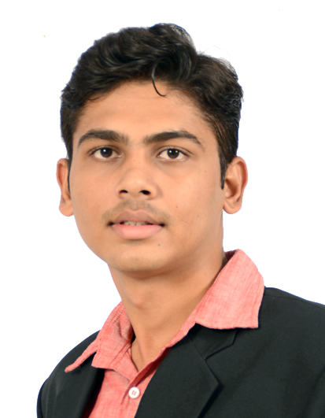
Panch Hatdi Chowk,
Near Parekh Nivas,
Jam-Khambhaliya - 361305
Gujarat (India).
Phone: (M) 9429796180
E-mail: sumitkanabar80@gmail.com.

Career Objective:

The main objective is to work in motivating environment where I can apply my skill and enhance the knowledge to make a sound position in front of global world. I can work with best of my efforts to achieve goal of the organization.

Professional Qualifications:

YEAR | DEGREE | COLLEGE/SCHOOL | UNIVERSITY/BOARD | RESULT-CLASS
2014 | M.B.A. | SHRI JVIMS, Jamnagar. | GTU | 70%

Educational Qualifications:

YEAR | DEGREE | COLLEGE/SCHOOL | UNIVERSITY/BOARD | RESULT
2012 | T.Y.B.B.A | S.V.E.T BBA College,  Jamnagar | Saurashtra University | 63.00%  First Class
2009 | H.S.C | G.V.J High School, Jam-Khambhaliya | G.H.S.E.B. | 53.00%  Second Class
2007 | S.S.C | S.N.D.T High School, Jam-Khambhaliya | G.S.E.B. | 76.00%  Distinction Class

Summer Training

I have taken summer training at STATE BANK OF INDIA for 10 weeks on research topic “Improving market shares in ASBA” (APPLICATION SUPPORTED BY BLOCKED AMOUNT).

Projects undertaken
- A project work at “APPLE INTERNATIONAL”, Jamnagar in MBA Sem-1
- Industrial Development Project - (Study on the importance of expansion in telecom sector with special reference to IDEA CELLULAR.)

Other curricular activities:

- Participated in the Event Organization of the College.
- Participated in many competitions at College like Group Discussion & Quiz Competition.

Computer Literacy:

- MS Office.
- Internet

Personal Details:

Birth Date : 15th August, 1992
Languages Known : English, Hindi, and Gujarati.
Gender : Male.
Nationality : Indian.
Hobbies : Travelling, Bike Riding, Movies.
Core competencies : Leadership skills, sincere, honest and committed to work.

Declaration:

I hereby declare that above information is true as per my knowledge.

Date: -
Place: - Jamnagar. (SUMIT KANABAR)

